**A group of hands holding each other

Description generated with high confidenceWashington State**

**UEB with Nemeth Course Materials**

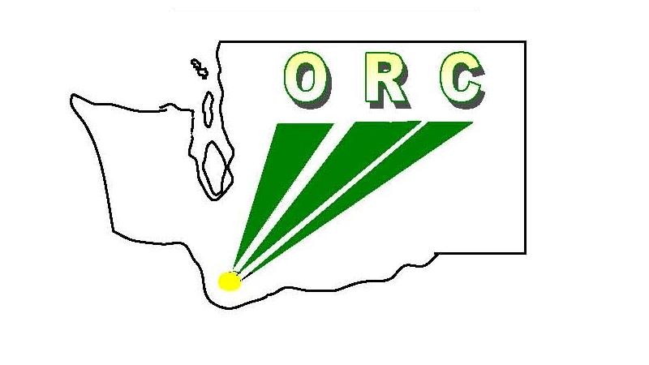Washington State School for the Blind

**Ogden Resource Center**

2310 E. 13th St.

Vancouver, WA 98661

***Applicant Information***

Contact Name _____________________________________________________________

Prison Program Name ______________________________________________________

Address __________________________________________________________________

City _________________________________________ State _______ Zip ________

Phone (_____) ______ - ________ E-mail ______________________________________

Additional phone (_____) ______ - ________

***Applicant Signature***: _____________________________________ ***Date*** _________

**Course Materials include:**

PowerPoint Presentations

Exercises

Daily Practice

Extra Practice

Quizzes (with correcting guides)

Resources

**Mail this completed form along with your $1500 payment (made out to ORC) to:**

**To pay by credit card:**

Email application to [braille@wssb.wa.gov](mailto:braille@wssb.wa.gov) and request an invoice in the body of your message

**Ogden Resource Center**

**UEB w/Nemeth Course**

**2214 E. 13th St.**

**Vancouver, WA 98661**

**Please allow up to 1 week for**

**email delivery of materials.**