From: FREE MATTER
For The BLIND
39 U.S. Code 4654

WSSB
Ogden Resource Center
2310 East 13th Street
Vancouver, WA 98661

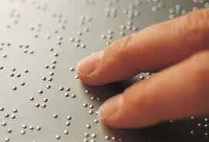
Braille Transcription
and Large Print enlarging
ONLY

From: FREE MATTER
For The BLIND
39 U.S. Code 4654

WSSB
Ogden Resource Center
2310 East 13th Street
Vancouver, WA 98661

Braille Transcription
and Large Print enlarging
ONLY

