From: FREE MATTER
For The BLIND
39 U.S. Code 3403

WSSB
Ogden Resource Center
2310 East 13th Street
Vancouver, WA 98661
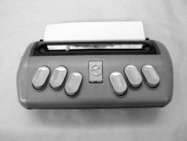

Electronics
Returns ONLY

From: FREE MATTER
For The BLIND
39 U.S. Code 3403

WSSB
Ogden Resource Center
2310 East 13th Street
Vancouver, WA 98661

Electronics
Returns ONLY

