From: FREE MATTER
For The BLIND
39 U.S. Code 3403

WSSB
Ogden Resource Center
2310 East 13th Street
Vancouver, WA 98661

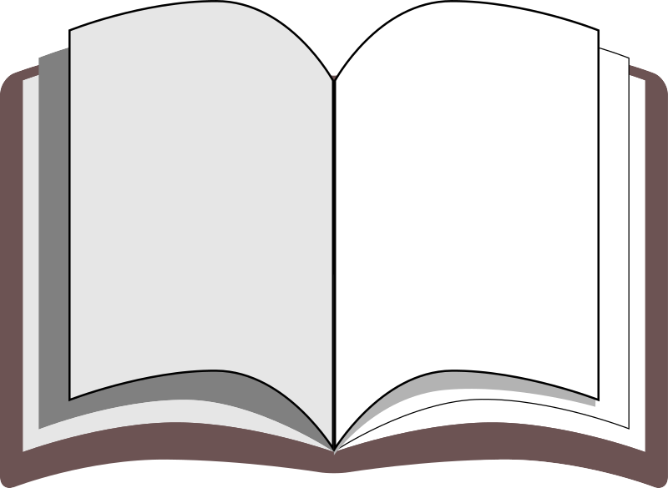
Braille
Braille book
returns only

From: FREE MATTER
For The BLIND
39 U.S. Code 3403

WSSB
Ogden Resource Center
2310 East 13th Street
Vancouver, WA 98661
Braille

Braille book
returns only

