Application Date:
ORC OFFICE USE ONLY
dbase
wltr
em new
em old
8/16/18
Account Holder Registration Form
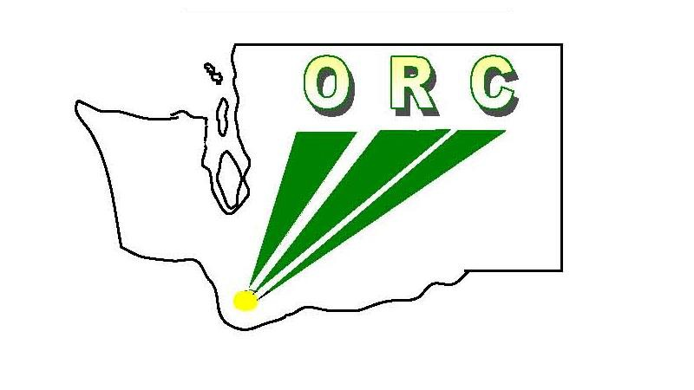
Ogden Resource Center
Print Form
Washington State School for the Blind 2310 East 13th Street
Vancouver, WA 98661-4120
1-800-562-4176 x. 183 or 360-696-6321 x. 183
Fax 360-737-2120 / Email irc@wssb.wa.gov

- Account Type: Select one of the boxes and complete the information for that selection.

School District ESD Agency Private Non-Parochial

Name: Number:
- Account Holder / Individual authorized to provide liaison function between the district or agency and Ogden Resource Center at WSSB. (Only one Account Holder per district.)

First Name Middle Initial Last Name
Note: Your order confirmations and

Email
Title (select best category below)

other ORC communications will go to this email.

Teacher of the VI

Parapro
Administrator
Other

Phone Number Fax Number

User Name Password

Note: Please choose your own User Name and Password.

First Mailing Address (Materials and correspondence for the Account Holder will be mailed to this address. Other shipping addresses can be added to your online account.)

Organization

Address 1

Address 2

City State Zip Code
Washington

Attention

Account Holder Signature:
I agree to serve as the Account Holder and assume the responsibility of having a system in place locally that provides for the tracking, care, and return of non-consumable books and materials in such a way that all borrowed books and materials are returned complete and in a condition that is considered “acceptable for re-use” according to the standard of care described in detail in the ORC Account Holder Booklet.

Account Holder Signature
- Signature of Superintendent, Director of Special Education, or agency administrator authorizing the above designation*. (Only if the account holder is not the Superintendent, Director of Special Education, or agency administrator.)

Signature
Title

Printed Name Date

* Superintendent, agency Administrator, Director of Special Education or other administrator who has authority for the program for students who are visually impaired and who would cause the requested non-consumable items to be accounted for and eventually returned, and who accepts the District's/Agency's financial responsibility related to missing or damaged books and materials.

Additional Email Address Please include email addresses of others who will be accessing the site or ordering materials through this account. This will assure they are included when important information is sent throughout the year.

Name

Email Address

Name

Email Address

Return this form to:
Ogden Resource Center
Washington State School for the Blind
2310 East 13th Street Vancouver, WA 98661-4120

Fax 360-737-2120
Email irc@wssb.wa.gov

Upon receipt of this form ORC staff will set-up your account and email you when activated

